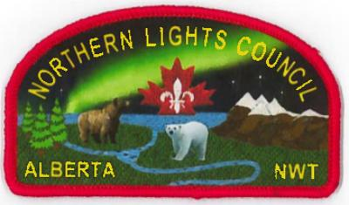
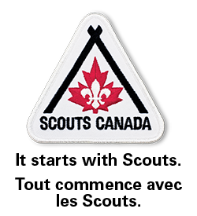

Northern Lights Council is proud to present the
2nd Annual Edmonton Eskimos Scout Night
with sleepover at Commonwealth
September 29 5:00pm Edmonton vs Winnipeg

Enjoy the game cheering on the Eskimos and then prepare for our unique sleepover event.
We will be pitching our tents around the field to spend the night.
Light Breakfast will be served

Get your tickets early from the Scout office to ensure that you get in on this exciting event. Limited number of space for the sleepover (800 max)
What a great way to start out the year.

Deadline to order is September 14, 2018

Please contact chris.cerhit@scouts.ca for more in formation

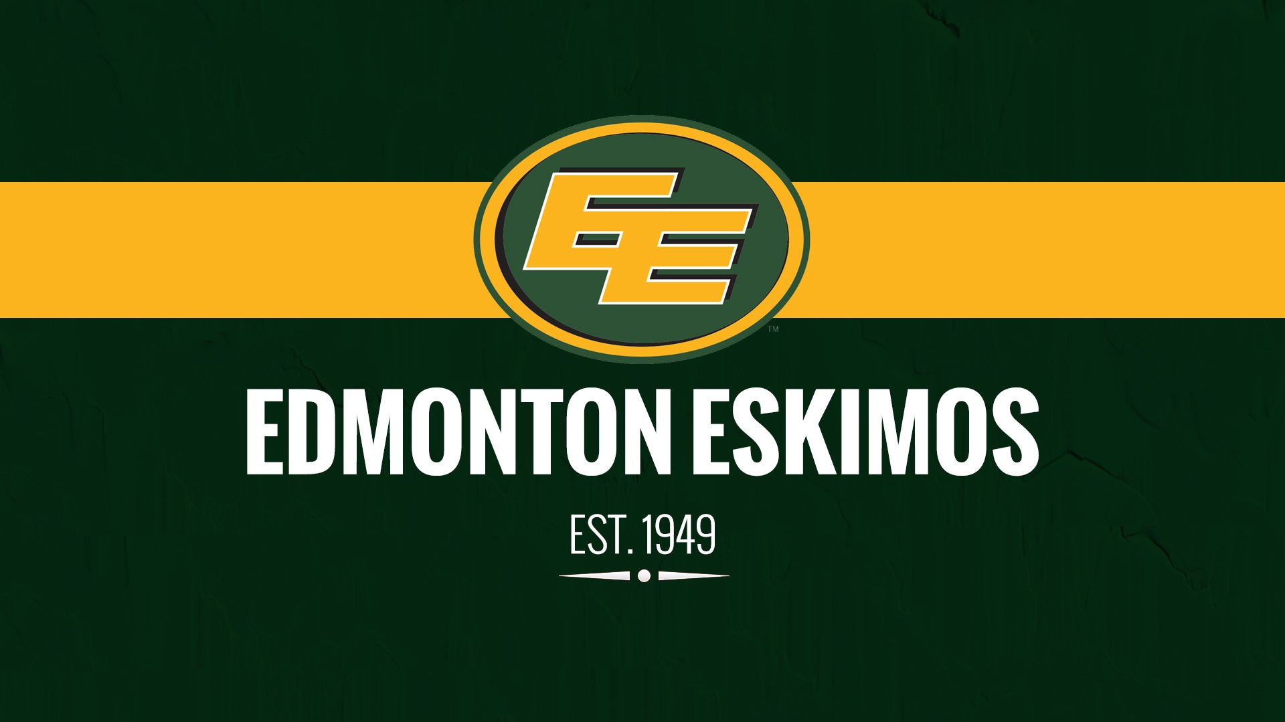

Ticket Order form

Group Name_____________________________________________________________

Group Contact ___________________________________ email: ______________________

Tickets required_____________________________________________

Sleeping Over no _____ yes ______
Participants sleeping over ___________________

Ticket Fee $25 per person

Ticket Requested ___________________ x $25
= ________________________
Make cheques payable to Scouts Canada Events

